Enclosure 1: Module (Unit) Specification (MS)
Module Lists
No. | Module ID | Module Name
1 | MS-001 | Measurement
3 | MS-002 | Alarm Management
4 | MS-003 | Data Storage
5 | MS-004 | Dashboard (Grafana-based) & Report

Module Specification
- Module Specification: Measurement (MS-001)
Module ID | MS-001
Module Name | Measurement
Description | The measured temperature data is processed and transmitted to the RPi.  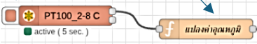  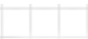  (Fig.1 Node-RED Data Processing Flow for MS-001)  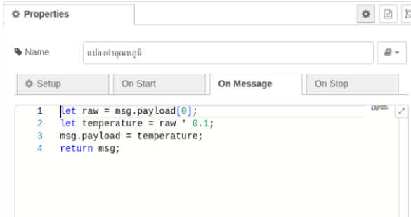  (Fig.2 Temperature Conversion Command)

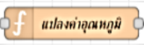
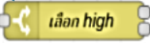
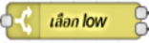
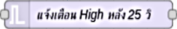
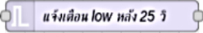
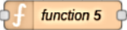
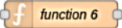



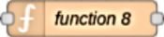


- Module Specification: Alarm Management (MS-002)
(Fig.3 Node-RED Data Processing Flow for MS-002)
Module ID | MS-002
Module Name | Alarm Management
Description | The RPi receives and processes the incoming data via Node-RED. When the temperature meets the specified threshold, the system triggers and sends an alert notification via Line and Telegram.

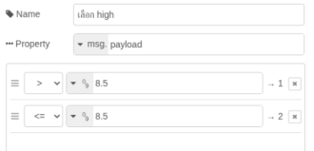
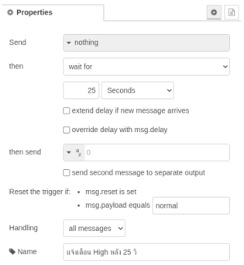
(Fig.4 Temperature and delay time settings for notifications)

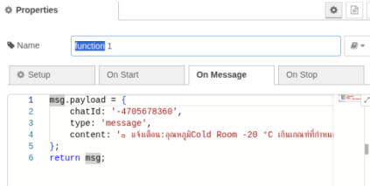
(Fig.5 Commands for transmitting alert notifications via LINE and Telegram)

- Module Specification: Data Storage (MS-003)
Module ID | MS-003
Module Name | Data Storage
  Description  (Fig.6 Node-RED Data Processing Flow for MS-003) | The RPi transmits the processed data to a VM Server for storage within an InfluxDB database.

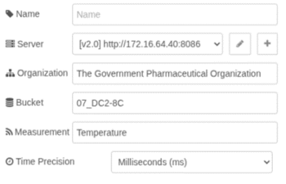
(Fig.7 Configuring data transmission to the InfluxDB database)

- Module Specification: Dashboard (Grafana-based) & Report (MS-004)
Module ID | MS-004
Module Name | Dashboard (Grafana-based) & Report
Description | Transforms stored raw data into visual analytical tools for real-time monitoring and historical reporting.
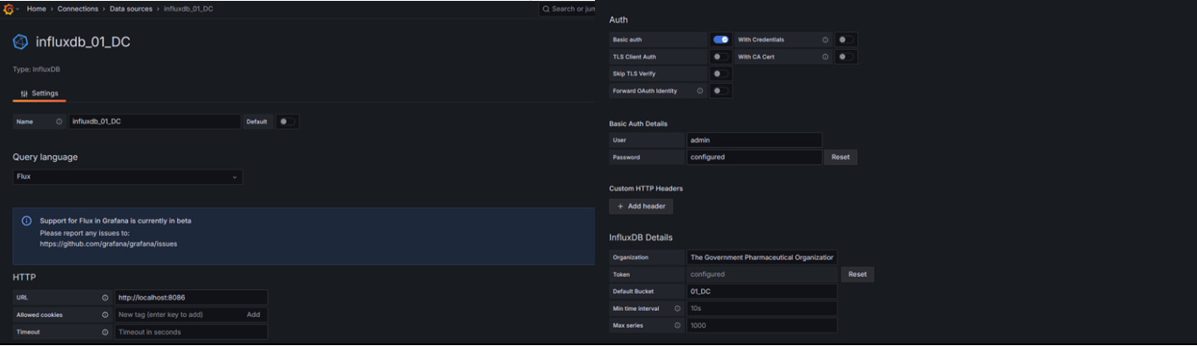
(Fig.8 Establishing a data connection to the InfluxDB database)

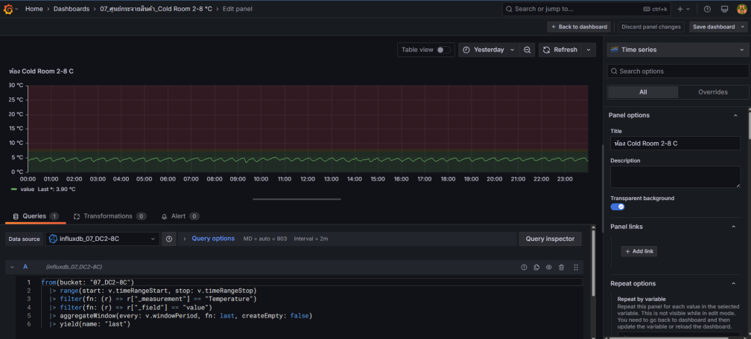
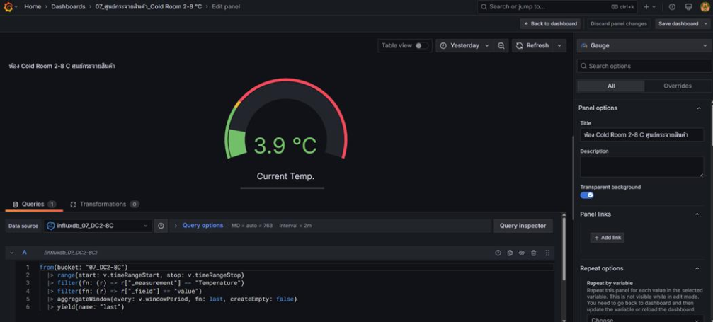
(Fig.9 Data retrieval queries for chart visualization)
(Fig.10 Data retrieval queries for gauge visualization)

